The new Thematic SREV: Innovation
Joachim Maas, Germany
According to the Thematic SREV, the criterion treatment is divided into three sub-criteria: title and plan (15 points), development (15 points), and innovation (5 points).
As innovation is the only "new" sub-criterion of the new SREV, it is worthwhile having a detailed look at it as exhibitors and jurors.
Innovation can be shown by
- new themes
- new overall concepts
- a new development of chapters or sub-chapters
- a new development of pages or parts of pages
- new thematic application of the material
To understand these five different possibilities and to distinguish between them, they are explained by using some examples.
New themes are demonstrated by the title and/or the subtitle of the exhibit. Nevertheless, new themes should not be evaluated without considering the concept. New themes with boring concepts, which only consist of simple lists and which do not reflect environment or cause and effect or consequences or cross-references and so on, are not innovative. So it is not only sufficient to deal with a new species of animals, a new sport’s discipline or a famous person never dealt with before, but such a new theme should be combined with an interesting plan. Consider the following fictitious example:
Umberto Miller, a famous composer
1. Precursors | 2. His Life | 3. His Works | 4. In memory of Umberto Miller
 | descent | chamber music
 | birth | symphonies
 | education | concertos
 | journeys | operas
 | last years
This concept is known from dozens of exhibits dealing with famous people. This is not an example of innovation, though the theme is completely new.
Of course, it is not always possible to create new themes. Therefore, new concepts are much more important than the theme itself.
New overall concepts can be demonstrated by subtitles and/or by plans. Considering the title of the famous exhibit Australasian Birdlife - a look at the bird world of the South Pacific region along zoogeographical lines, we realise a new theme combined with a completely new concept: the zoogeographical approach, which enables the exhibitor to demonstrate a lot of really new, important and interesting aspects.
Consider a second example. Exhibits dealing with papermaking, printing, book publication and the press are usually divided into four or five parts: (writing), paper making, printing, book publication and the press. These chapters then are dealt with separately, each chapter covering a very large period, without reflecting their mutual influence. So to avoid these disadvantages, the following new concept shows a clear historical evolution emphasizing the interdependence between the technical and the historical development:
Printing and papermaking, motors of book publication and the press
1. Putting down written information before the invention of typography
2. The invention of printing by movable types about 1440
3.... gives impetus to book publication and the press since 1500
4. Progress in papermaking and printing techniques since about 1800 ...
5. ... supports modern book publication and the modern press
The third possibility of demonstrating innovation is a new development of chapters or sub-chapters. Let us have a look at an example: The evolution of writing. The usual approaches emphasize the appearance of "characters" (pictograms, cuneiform writing, hieroglyphs, ...). Such approaches do not demonstrate the very essence of the development of writing. So the following new approach puts more emphasis on how the "characters" represent the content and later on the phonetic structure of languages. This concept combines examples from different cultures on one page and results in the following headings of the pages ( fig 1), (fig.2), (fig3), (fig4) and (fig 5):
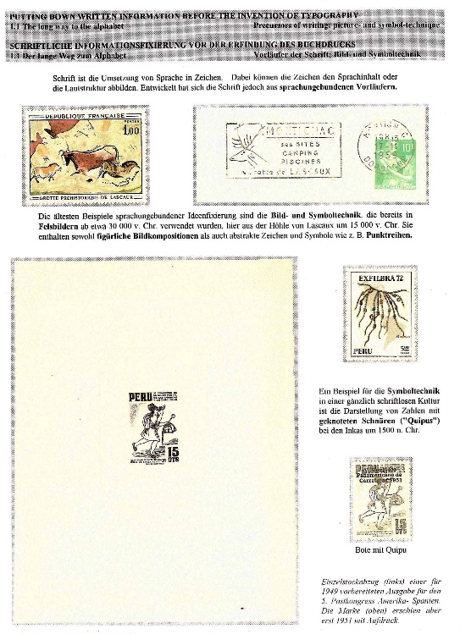 fig 1
- Precursors of writing: picture- and symbol-technique
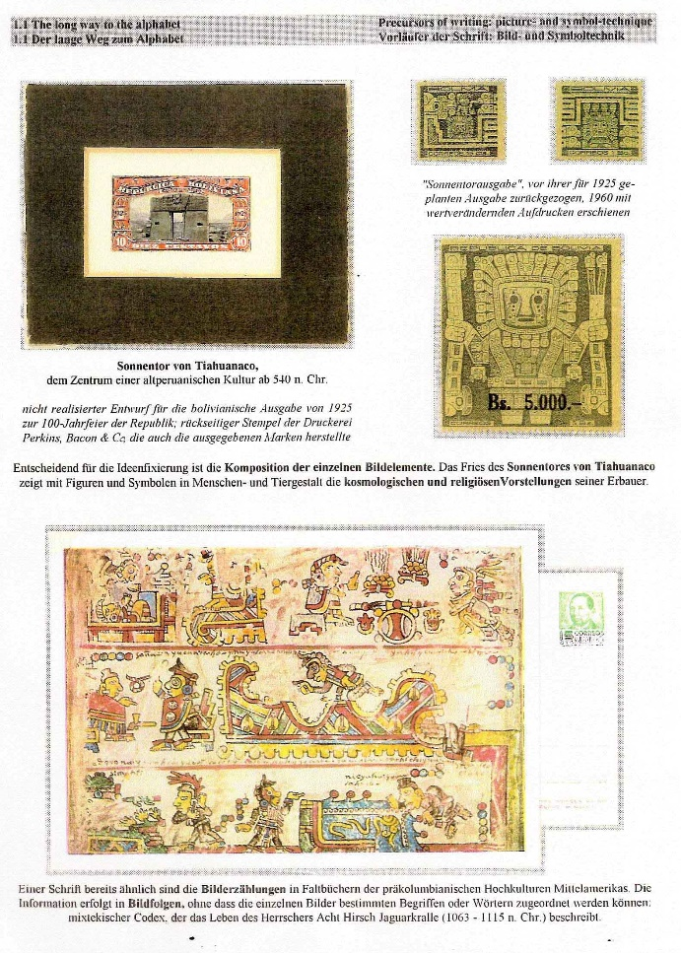fig 2
- Logography, representing the content of languages
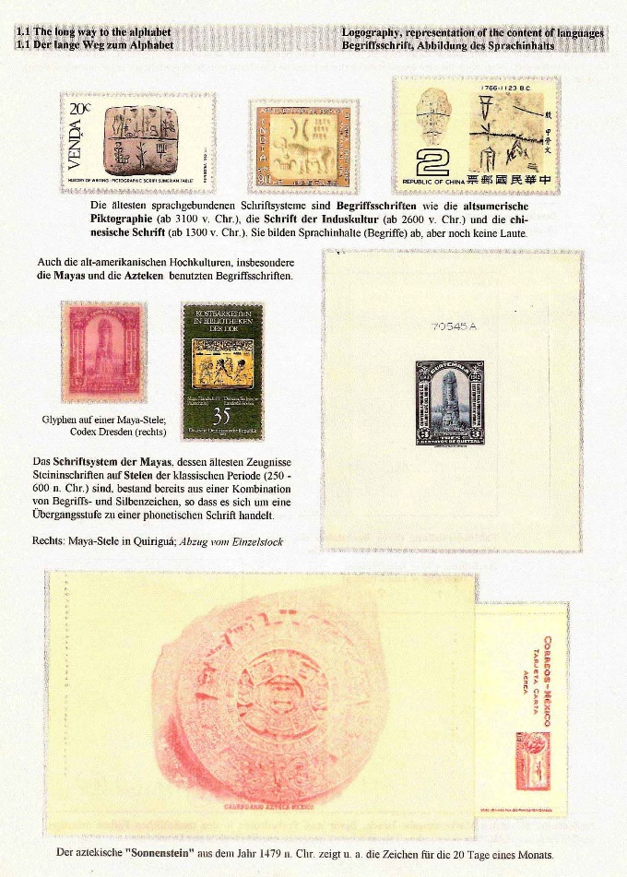fig 3
- Beginning of phonetic writing
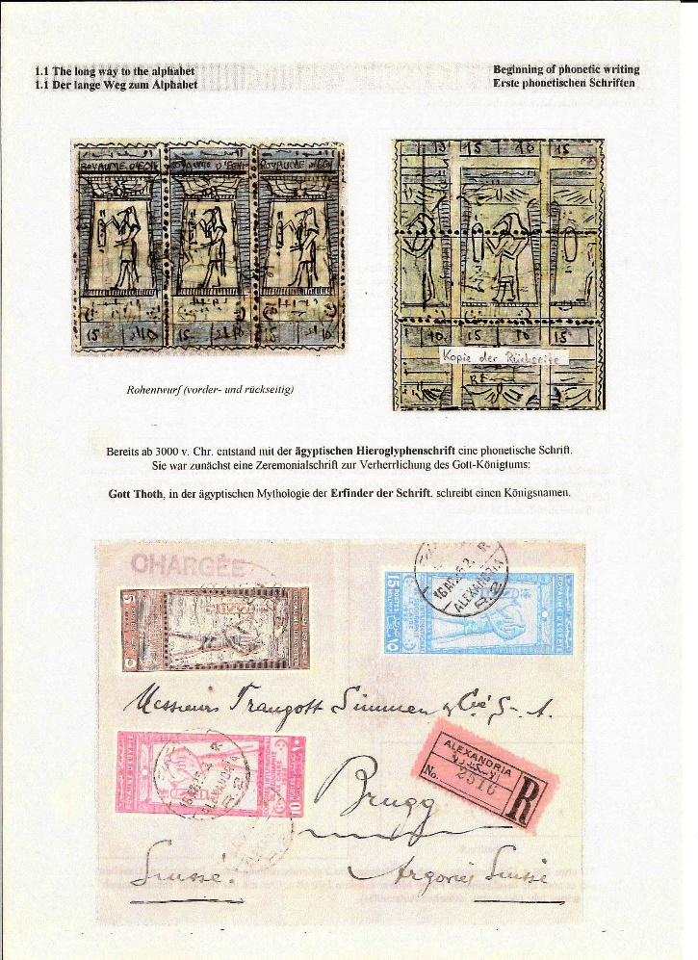fig 4
- A revolutionary development: first alphabets
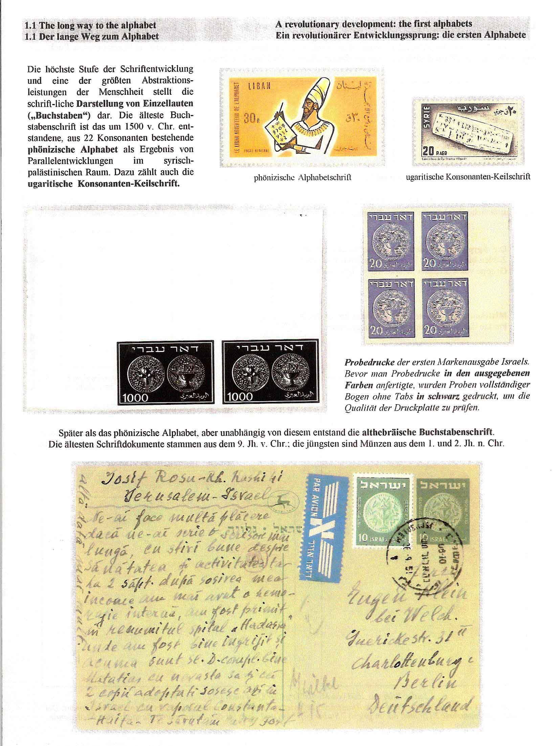fig 5
Often it is not possible to create new overall concepts or new development of complete chapters. Therefore exhibitors can use a fourth possibility of demonstrating innovation: new development of pages or new thematic interpretation of items. Consider three examples:
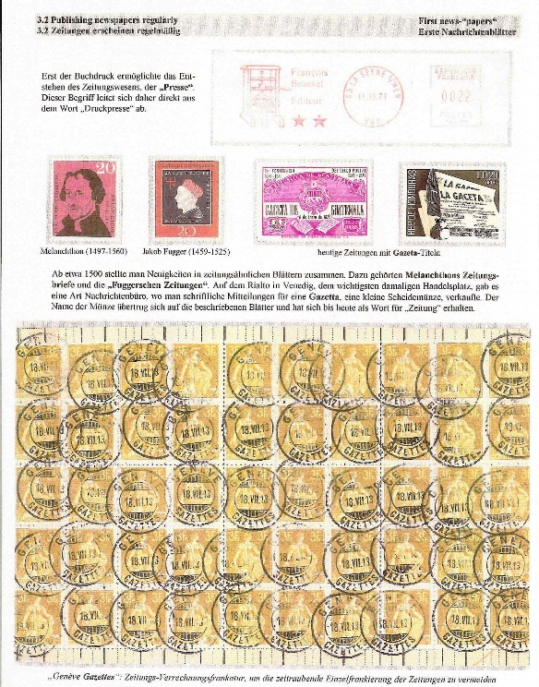fig 6
Figure 6 is taken from the thematic field "the press" and shows a new thematic interpretation of the cancel "Genève, gazettes". This item should have been expected in a subchapter dealing with the distribution of newspapers. Here it is interpreted in the following way: In the 16th century written news-"papers" were sold on the "Rialto", a central place in Venice; the price was one "gazetta", and the name of the coin was transferred to the papers so that gazette has become a synonym for newspaper up to now.
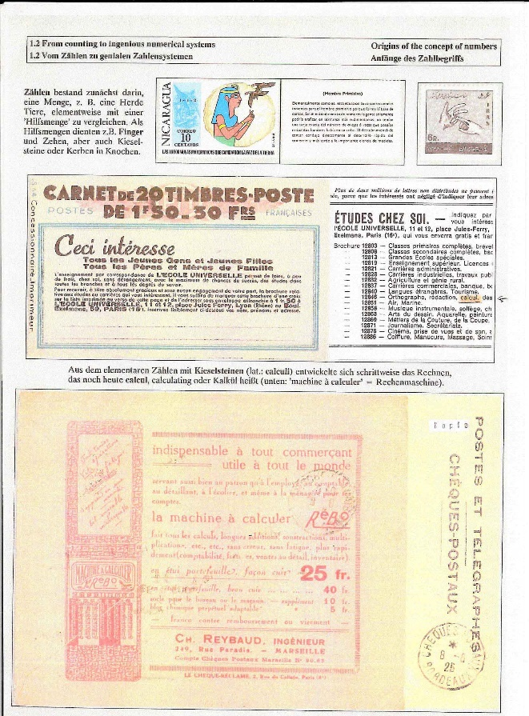fig 7
Figure 7 is taken from an exhibit dealing with mathematics and shows an etymological interpretation of the word "calculate": Calculating developed from counting with pebbles (Latin "calculi").
As for the last two examples, one might object that these are excellent examples for demonstrating thematic knowledge, but they don't demonstrate innovation. Of course, both examples are strongly based on thorough thematic knowledge. The use of the items in this thematic connection is so surprising that the combination of the thematic statement with the items demonstrates innovation.
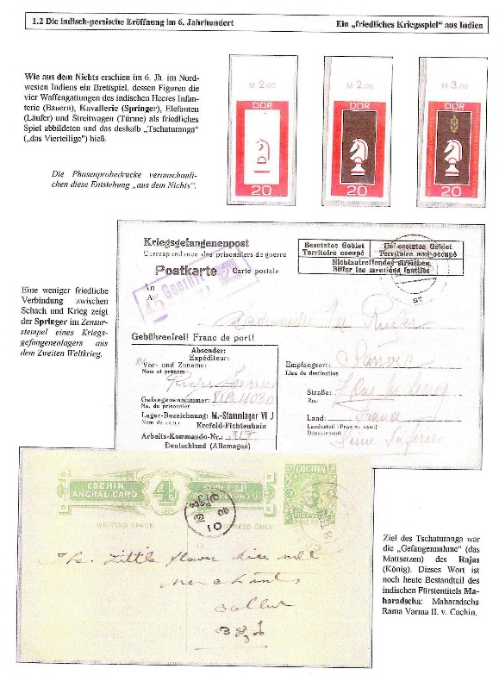fig 8
Figure 8 shows a thematic interpretation of philatelic varieties. The three stamps with the knight philatelically demonstrate the steps of the printing process, and the thematic text says: "As out of nothing a game like chess appeared ....".
In figures 6, 7 and 8 items are used which are not new for the whole theme, but which are interpreted in a new and surprising way or which are used in an unexpected subchapter. Furthermore, a fifth possibility of demonstrating innovation is the application of items which - in the thematic sense - are completely new for the whole theme. Consider three examples.
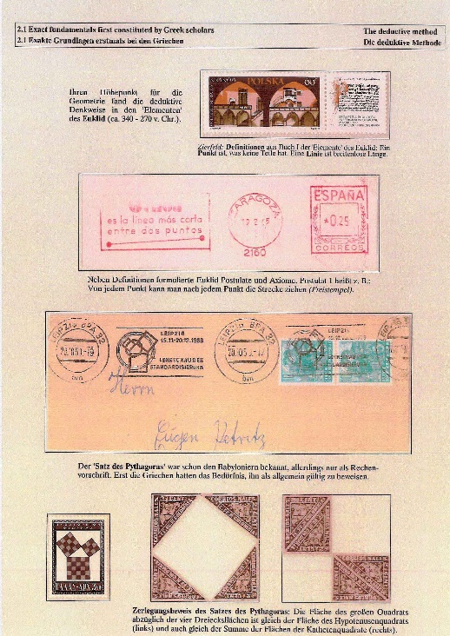fig 9
Figure 9 shows a proof of Pythagoras’ theorem using 8 Columbian triangular stamps.
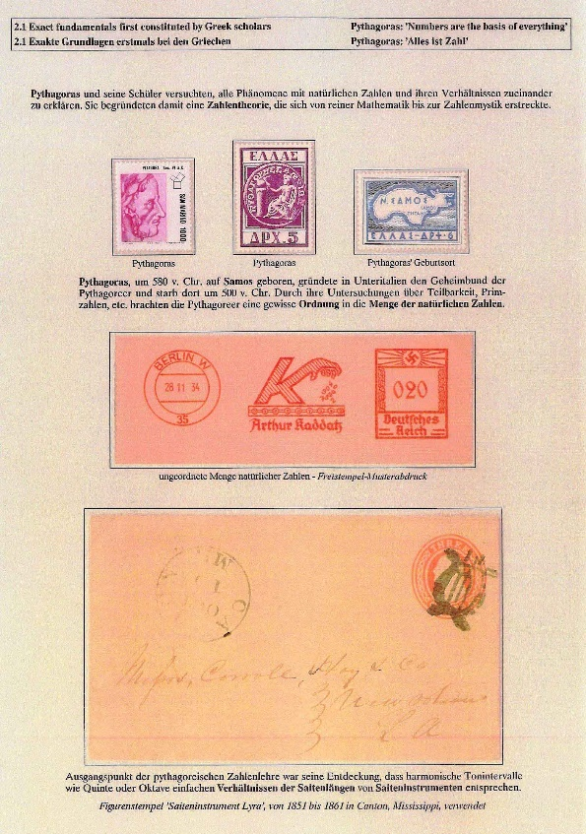fig 10
Figure 10 is also taken from the thematic field of mathematics. The page deals with the Greek mathematician and philosopher Pythagoras, who tried to explain nearly everything by the proportion of numbers. You would expect the US fancy cancel from the classical period showing a lyre to be integrated into an exhibit dealing with music rather than in a connection with Pythagoras. The thematic reason is that the starting point for Pythagoras' theory was the discovery that harmonic intervals are based upon simple proportions of the length of strings of musical instruments like the lyre.
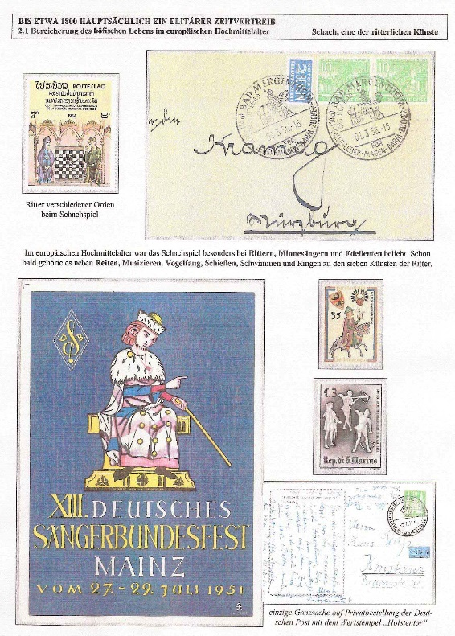fig 11
The last example (Figure 11) is taken from an exhibit about chess and shows items, four of which would not be expected in this field of the theme. The text explains that at the end of the European Middle Ages chess was especially popular among knights and minstrels and so became one of the knightly arts, besides e. g. riding, music, bird-catching and archery.
To summarize, we have seen that there are a lot of possibilities of demonstrating innovation and that innovative concepts or development and surprising elements are much more important than the creation of new themes. So, this new sub-criterion is a chance for exhibitors more than a risk.
On the other hand, jurors should try to avoid the risk of allotting too few points because of taking into account the same mistake or omission several times. According to the new SREV, innovation should no longer be taken into account when deciding about the points for plans or development. As for the evaluation of plans, the new SREV explicitly does not contain the former aspects of originality and creativity any longer.
Proposal for allotting points for the sub-criterion of innovation:
Known themes combined with simple concepts: | 0 – 2
New themes combined with simple concepts: | 3

Known themes combined with good concepts
good development and some/ a lot of new items: | 3 – 4

New themes combined with good concepts
good development and some/ a lot of new items: | 4

new or known themes combined with innovative concepts or
innovative development or a lot of new items: | 5

